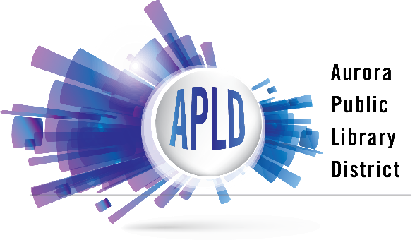
COLLECTION DEVELOPMENT POLICY

Aurora Public Library District Vision

Where Aurora Comes Together To Discover, Create, Connect, and Succeed.

Collection Development Philosophy

The Aurora Public Library District provides materials that inform, educate, enrich, and entertain our customers as individuals and as a community.

Purpose

This Collection Development Policy has been adopted by the Board of Library Trustees of the Aurora Public Library District to guide library staff and to inform the public about the principles upon which collection development decisions are made.

The Library endorses the American Library Association’s Library Bill of Rights (http://www.ala.org/advocacy/intfreedom/librarybill) and Freedom to Read statement (http://www.ala.org/advocacy/intfreedom/freedomreadstatement).

Responsibility for Selection

Ultimate responsibility for the library’s collection rests with the Executive Director, who operates within the framework of policies determined by the Board of Library Trustees. Library staff select materials based on their knowledge of community needs and the criteria outlined in this policy.

Selection

The following criteria serve as guidelines
- Community needs and demands, both demonstrated and anticipated
- Value and accuracy of information
- Authority and reputation of the author
- Representation of various viewpoints
- Representation of resident native languages
- Relevance to the experience and contributions of diverse populations
- Price, format, and production quality
- Special considerations are given to local history/archival materials pertaining to Aurora’s history

Collection Maintenance

Items may be withdrawn from the library’s collection to ensure a collection that meets the community’s needs and demands. Items may be withdrawn due to:

- Low usage/checkouts
- Multiple copies no longer needed
- Outdated or inaccurate information
- Physical condition
- Space limitations
- Availability of similar information in online resources
Withdrawn items may be placed in the library’s book sales, donated to other nonprofit organizations or otherwise recycled or discarded.

Local Author Collection

The Aurora Public Library’s Local Author collection is designed to promote a reading culture in Aurora and to support the local arts community. To be considered for the library’s Local Author collection you must:

- Complete the Local Author Donation Form and submit it with your work
- Be an Illinois resident
- Donate copies of your work
All items donated by local authors:
- Become property of the Aurora Public Library
- Cannot be accepted as unpublished or unbound materials, ebooks or other digital content
- Are subject to collection maintenance criteria and may be withdrawn from the library’s collection following the criteria outlines in this policy
Donations
The library happily accepts donations of materials for consideration for the library’s collection or for the library’s ongoing book sale. These items:

- Must be given unconditionally and will not be returned
- Will become property of the library and the staff will determine what will be added to the library’s collection
- The library will in its sole discretion discard, recycle, or sell materials not added to the collection.
Requests for acknowledgement must be made at the time of donation.
Reconsideration of Library Materials

Any Aurora Public Library District resident may request the reconsideration of an item already in the library’s collection. A resident must complete a Request for Reconsideration form or write a letter that includes the information asked for on the form. Procedures have been established to ensure serious and timely review of a request for reconsideration of library materials. Until a decision has been reached the item will remain in circulation.

A written reply will be sent to the resident, and if the resident is dissatisfied they may submit a final written request for reconsideration to the Board of Library Trustees for its review and final decision.

Approved by the Aurora Public Library Board of Library Trustees
August 25, 2021

